THE CORRELATION BETWEEN STUDENTS’ LISTENING COMPREHENSION AND THEIR ABILITY TO RESPOND DIRECT QUESTIONS
(A Study Conducted to the Seventh Semester Students of Pakuan University)
A Paper
Submitted to the English Study Program Faculty of Teacher Training and Educational Sciences Pakuan University as in Partial Fulfillment of the Requirements for the Sarjana Pendidikan Degree

By:
Rikza Fahmi
0311 11 099

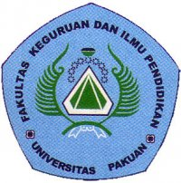

ENGLISH EDUCATION STUDY PROGRAM
FACULTY OF TEACHER TRAINING AND EDUCATIONAL SCIENCES
PAKUAN UNIVERSITY
2017

